SELCUK UNIVERSITY

FACULTY OF ARCHITECTURE AND DESIGN

DEPARTMENT OF FASHION DESIGN
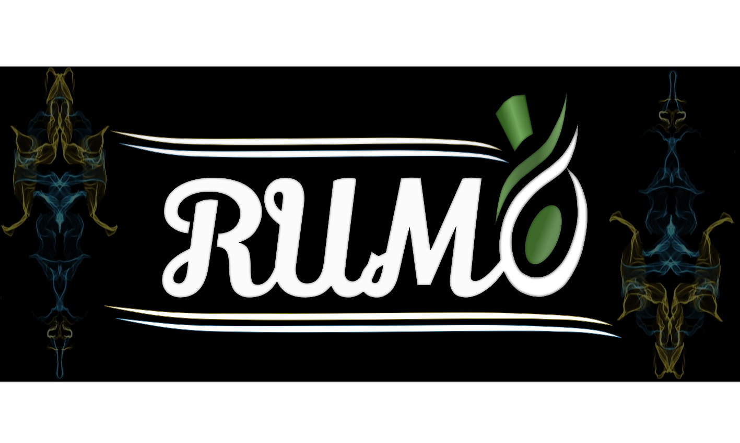

RUMI INTERNATIONAL JURIED ONLINE MIXED EXHIBITION (INTRKS2024)
“Meeting in the Light of Rumi”

23 – 27 December 2024
MANIFEST
RUMI: Meeting in the Light of Rumi
Art is a universal language that touches the deepest corners of the human soul. Guided by this language, we present our group exhibition "RUMI: Meeting in the Light of Rumi", focusing on the philosophy of the great thinker Mevlana Celaleddin RUMI, who lived in Anatolia in the 13th century, and in order to combine the teachings of Mevlana Celaleddin Rumi with art.
Rumi has been the voice of love, tolerance, unity and the inner journey of man. This exhibition aims to bring together works from different art disciplines as a response to Mevlana's call "Come, whoever you are, come again". The exhibition features a wide range of works from painting to sculpture, from photography to digital, from innovative forms of contemporary art to textile and fashion design, as well as Universal messages that Rumi says, "You are nothing but thought, the rest is flesh and bone”, “You think of roses, you become a rose garden.”, “Let’s create new meanings together in Rumi’s rose garden.”, “Share your art with us, let’s be light together!”, “Come, because this exhibition is for you; come, because this light embraces everyone.” will be reinterpreted.
We invite you to answer the those questions from Rumi in your own artistic language:
-“What is love and how does it transform us?”
-"How can we be a light together?"
- "How do we tell the journey of the soul through art?"
The main purpose of our exhibition is to make visible through art the understanding of inner peace, love and unity that Rumi gifted to humanity and to give the audience this unique spiritual experience. With this group exhibition, we aim to open a window not only to Rumi's ideas, but also to the aesthetic richness of his age and its echoes in today's world. The exhibition invites you to come together on this spiritual and artistic journey and discover your own inner journey in the light of Rumi's teachings, with the compassion of Mevlana embracing everyone by saying "Whatever you are" and the spiritual transformation he expressed by saying "I was raw, I was cooked, I was burned".
This exhibition will not only be an art event, but also a meeting, a dialogue and a journey of inner discovery. Let us come together in the light of Rumi and celebrate this deep spiritual heritage through art.
CONDITIONS OF PARTICIPATION:
- The theme of the exhibition is “RUMI: Meeting in the Light of Rumi”. The works/designs must be in line with the theme of the exhibition. Works/designs that are outside the theme will not be accepted.
- The exhibition is open to different design and art disciplines such as fashion and textile design, textile art, traditional arts, sculpture, ceramics, visual arts and digital design.
- The exhibition is open to applications from artists and designers, those studying in the field of art and design, and undergraduate graduates and postgraduate and doctoral students who have completed their education in these fields.
- For all areas, the use of work dimensions, techniques and materials are free.
- Participants can apply with a maximum of 1 work/design that has not been exhibited or awarded before. (With this application, the participant declares and undertakes that the work/design he/she sends is original. In case of any dispute that may arise on this issue later, the owner of the work/design is the addressee of the relevant issue. The Exhibition Organizing Committee is not responsible for this situation).
- In order to participate in the exhibition, exhibition participants must fill out the published “Application Form” completely by December 13, 2024.
- The artwork must have a resolution of 300 DPI, be at least 2200x1700 pixels, and be sent in JPEG format. The artist photo to be uploaded in the form must be named as name-surname. Work images should be uploaded by coding them as name-surname initials, work title and field. For example; A.P. Anka. Fashion Design
- Participants who wish to join the exhibition must complete the Exhibition Application Form using the provided link (https://forms.gle/vcRbRVB8nd7mN94s5) in the required format and without missing any details. Additionally, they must upload the Artwork/Design Image and the Participant Information Form to the specified sections in the link no later than December 13, 2024. Applications with unclear artwork/design images, images that do not meet the specified requirements, or submissions made after the deadline will not be considered.
- For the work/works, 1 photograph taken from a clearly visible front angle must be uploaded. For three-dimensional designs, photographs or detail images taken from different angles should be saved in a single arrangement and uploaded to the system.
- The submitted work/design will be evaluated by the jury. Works/designs rejected by the jury will not be exhibited. A letter of acceptance will be sent to the participants for the works/designs selected by the jury.
- The works will be exhibited online The exhibition catalogue will be published after the exhibition. Participants will receive their certificates and the exhibition catalogue by 20.01.2025 at the latest.

IMPORTANT DATES

Exhibition Application Start Date: November 29, 2024

Deadline for Application: December 13, 2024

Exhibition Opening Date: December 23, 2024

Exhibition End Date: December 27, 2024

Communication :

Honorary President

- Prof. Dr. Hüseyin YILMAZ / Rector of Selcuk University

- Prof. Dr. Rabia KÖSE DOĞAN / Dean of Faculty of Architecture and Design, Selcuk

University

Organizing Committee President.

Prof. Dr. Hatice HARMANKAYA / Head of Selcuk University Fashion Design Department

Organizing Committee

Asst. Prof. Dr. Ahu Fatma MANGIR

Asst. Prof. Dr. Ayşegül PARALI

Asst. Prof. Dr. Asuman YlLMAZ FİLİZ

Asst. Prof. Dr. Selma DOĞAN DOLANBAY

Dr. Derya ÇELİK

Jury Board
- Prof. Andreas SICKLINGER (İtalya)
- Prof. Monica KOSTRZEWA (Polonya)
- Prof. Dr. Ayşegül KARAKELLE ALPER (Türkiye)
- Prof. Dr. Emine KOCA (Türkiye)
- Prof. Dr. Emine NAS (Türkiye)
- Prof. Dr. Kübra ALİYEVA (Azerbeycan)
- Prof. Dr. Ljubica Knezevic CVELBAR (Sırbistan)
- Prof. Dr. NİHAN SEMEN UZAR (Türkiye)
- Prof. Dr. Nurgül KILINÇ (Türkiye)
- Prof. Dr. Uğur ATAN (Türkiye)
- Prof. Dr. Ziynet ÖNDOĞAN (Türkiye)
- Assoc. Prof. Dr. Karım MİRZAEE (İran)
- Assoc. Prof. Dr. Mihaela TĂTULESCU (Romanya)
- Asst. Prof. Dr. Ahmet AYTAÇ (Türkiye)
- Asst. Prof. Dr. Eve Chan Man HIN (Hong Kong)
- Asst. Prof. Dr. Gökçe UYSAL BAŞER (Türkiye)
- Dr. Akgül KYRYJBAYEVA (Kazakistan)
- Dr. Aisulu KOPONOVA (Kırgızistan)
- Dr. Johnson Olarind OLADESU (Nijerya)
- Asst. Prof. Daniella MARTIN (Kanada)
- Julianna Illes MAJOR (Macaristan)

Curators and Exhibition Identity Design

Asst. Prof. Dr. Ayşegül PARALI

Online Presentation

Dr. Derya ÇELİK

Exhibition Catalogue

Asst. Prof. Dr. Asuman YlLMAZ FİLİZ

Secretariat

Asst. Prof. Dr. Ahu Fatma MANGIR

Asst. Prof. Dr. Selma DOĞAN DOLANBAY

Contact

Faculty of Architecture and Design Fashion Design Department,

Campus of Alaeddin Keykubat, Selcuk University,

Selcuklu/KONYA

Number

0332) 223 1765 – 1769- 1770 – 1796

Web Sitesi

https://www.selcuk.edu.tr/Birim/Bolum/sanat_ve_tasarim-moda_tasarimi/15460/Press/duyurular/%22rumi%22-uluslararasi-jurili-cevrimici-karma-sergi/31143

Exhibition Application Link

https://forms.gle/vcRbRVB8nd7mN94s5

Mail: intrib2024@gmail.com

